6-

7-

8-

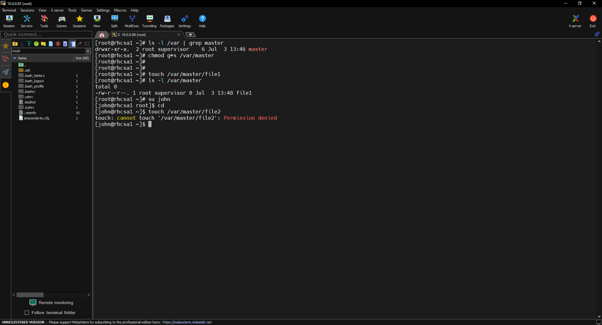

9.

10.

11-

Method 1

Method 2

Next ….

12-

13-

14-

15-

16-

17-

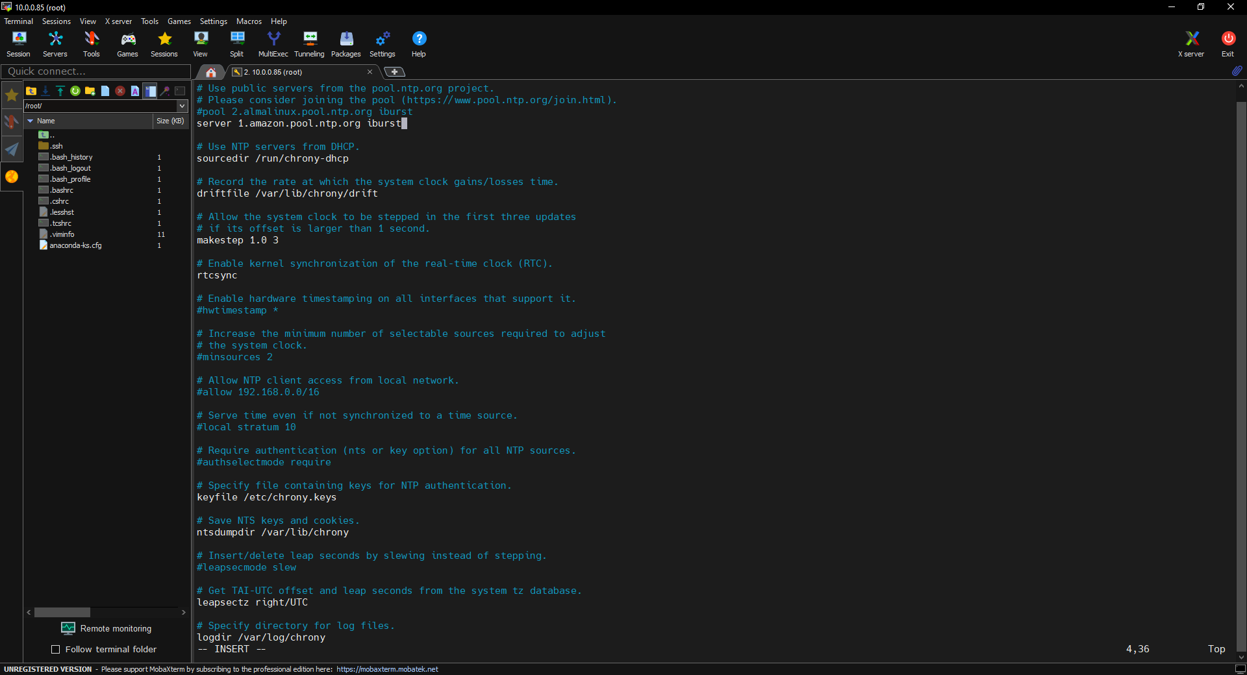

18-

19-

20-

21-

22-

